Root Imaging and Preparation: Guidelines and Instructions
Modified by E.B. Moore January 15, 2021

The following is meant to be a guide for scanning and preparing roots for analysis in the Root Phenomics Lab at the Noble Research Institute. The last update of this guideline is September 2020.
Equipment
The equipment that we use includes:
- Scanner: EPSON Expression 12000XL photo scanner with transparency unit
- Manufacturer’s scanning software, here Epson Scan 2
- Plastic forceps (not metal as it will scratch the trays)
- Scissors
- Water
- Plastic tray
- Water (between 400 to 450 mL)
Once you have the following equipment gathered, make sure the “Epson Scan 2” software is operational. Only one user can operate the software per login at a time, so if you lock or switch accounts, the software will not be accessible to anyone else until it has been closed.
Another detail to keep in mind is that the EPSON scanner you operating needs to be turned on, otherwise the software will not open. In either situation, an error message will appear to notify you if have not met those conditions.
Once you’ve successfully opened the software, you will need to adjust the following features to appropriate settings, or load the saved settings. This is so we can accurately measure and analyze the roots.
- Scan Settings: Not selected
- Mode: Photo Mode
- Document Source: Transparency Unit
- Document Type: Color Positive Film
- Image Type: 16-bit Grayscale
- Resolution: 600 dpi
- Scanning Quality: Standard
- Input Image: 11.10 x 15.30 in.
These settings guarantee excellent quality of the scanned sample in question while simultaneously using a minimum amount of time to acquire it (1 minute at most); higher quality means a longer amount of time to acquire the image.
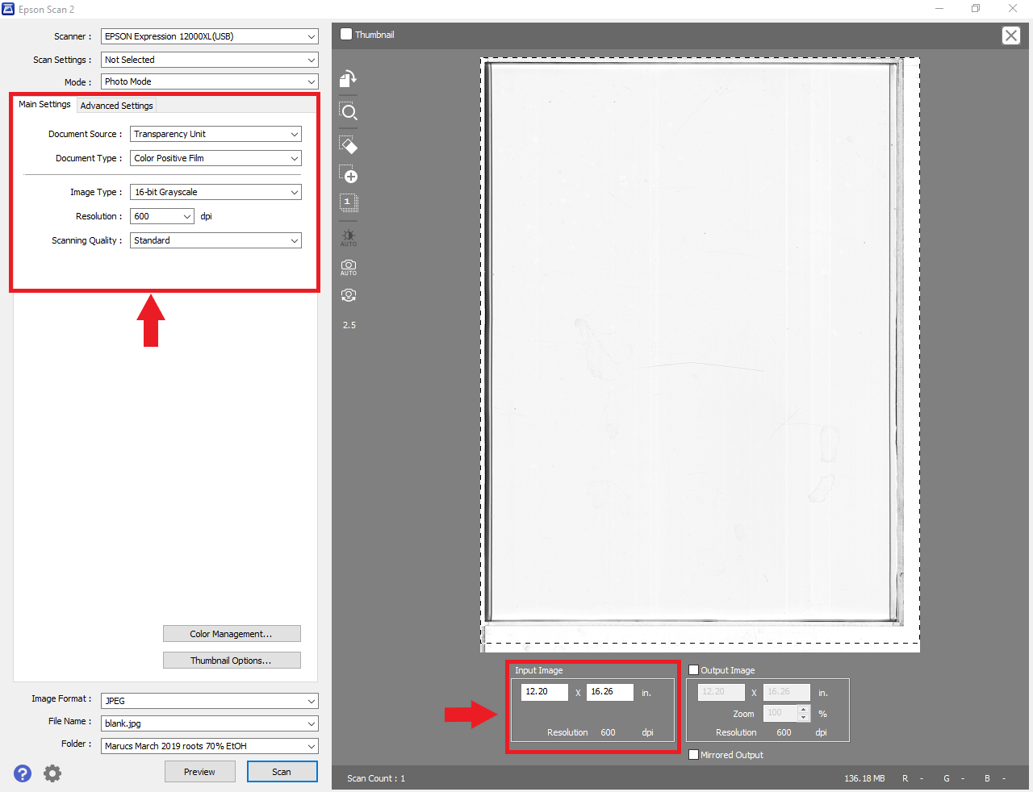

These are the locations where you can make adjustments. The input image has been adjusted to fit all of the plastic container for this example.
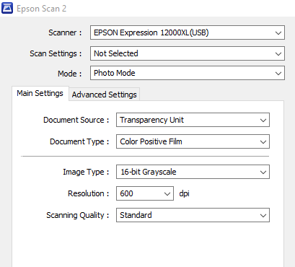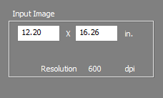

Note that the Input Image in the pictures do not match the settings mentioned earlier. If scanning were to commence on the plastic tray in the scanner, this image would result:

When the Root Phenomics Lab analyzes root samples using image analysis, the software used analyzes the sillouhettes of the roots. The borders, if included in the scan, will be analyzed by our software too, and need to be cropped out. The image should look closer to:


No border included in the scan. The white streaks in the image indicate that the scanner glass is dirty near the scan initiation and should be cleaned.
Procedure
- Place the plastic container onto the scanner within the alloted space.
- Designate the name and location file of the sample you’d like to scan.
- Fill the container with up to 400 to 450 mL of DI water. 400 mL is enough to cover the base of the container, while 450 should be enough to cover the roots if they are larger than seedlings.
- Separate root biomass from leachate using 425µm sieve. Be sure to retain all leachate and keep it in its original labeled bottle.
- Place the root biomass into the tray water.
- Make sure as much if not all of the roots are submerged into the water.
- Begin by using your forceps to gently pry and separate each root from one another. Make sure that no two roots overlap. Be gentle with your sample, as we need to have the roots as intact as possible. Although there will be moments where this can be about impossible where fine root hairs are concerned, roots from seedlings are especially fragille and need to be treated as such.

If that turns out to be increasingly difficult (too many roots, or if they are too large) then you may have too much sample for the tray. If that is the case, you may need to divide your sample into two or more multiple samples and take multiple images. The data must be aggregated during statistical analysis [note from Larry, we can provide some standardized script to do this. Things like lengths can be summed, but things like average diameter can not]
- Once you have successfully separated the roots, bring the cover completely down onto the plastic tray and proceed to press, “Preview” and review the sample. Examine, and make sure there is sufficient space between your sample and the boundaries you set up on the Input Image. The scan does not occur along the dotted line, and will crop part of your sample if the root is too close to the edge. Make adjustments to your sample as necessary.
- Once you’ve made your necessary adjustments, press the Scan button. The scan should take up to 1 minute to complete under these settings, to which you should be prompted with the option of viewing the scan soon after. Double-click on the file to make sure the scan captured the image properly while checking for bubbles, tray edges, and roots out of water. If the scanned sample is to your satisfaction, proceed to the next sample.
- Proceed to clean the tray by bundling up your sample in order to scoop it out and back into its container. Be sure to get as much of the root into the container as possible, including the finer hairs, otherwise they will show in the next scan. Some sample loss is inevitableso be prepared to change the water in your tray after a certain number of samples. Once the previous sample has been removed, proceed to the next sample, repeating steps 1-7.
- Once all of your scanning has been completed, proceed with cleaning your plastic tray: empty the water through a filter into the sink, and throw the debris into the trash. Proceed to rinse the tray with water until clean, then dry with paper towels. Set the tray with the others when finished.
- Make sure your scans are in a drive you can access at your computer. Close out of the Epson Scan program, and proceed to log off the computer.
Pro tips: bent roots that reach out of the water can be cut at the bend
The desired output with roots is as such:
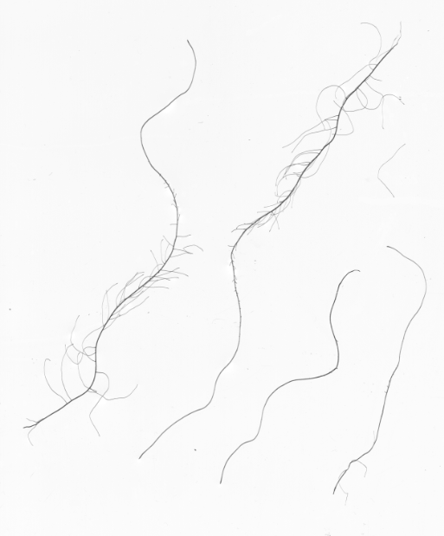

*Individual scans usually take from 5-15 minutes to complete.

Using RhizoVision Software
- Set new settings or load saved settings (file name metadataEBMroot).
Settings Checklist:
Broken Root Mode
Image thresholding level ~ 230
Filter non-root objects ~ 1
root pruning threshold ~ 5
set root diameter bins: 0-0.5, 0.5-1.0, 1.0-1.5, 1.5-2.0, 2.0 <

- Set desitnation file names using sample IDs. Be sure to us proper formatting (e.g. no spaces) for easy file transfer to R script.

- Click run or use Batch Mode to process mulitple samples simulateanously. For Batch mode be sure to crop images prior to running to make sure that the tray edges are not being read by the software. Aslo save both the image file and the Features data into a dedicated folder (i.e. Rhizo Data)

Post-Scan Processing
- Label aluminum pans and small sealable plastic baggies with sample ID information

- Root biomass samples are placed into their corresponding labeled pans in prepartion for drying. Minimize excess water in the pan by straining again if needed. Oven dry at 60°C for 24 hours. After drying has been completed, weigh the dry root biomass (use a scale accurate to the hundreths place) and record the weight.
Place dry root biomass into its corresponding labeled plastic baggie. These dry root sample will be ground and analyzed for TC,TN.

- Leachate will be retained in its original labeled glass containers after root solids have been separated out. Acid will be added to minimize microbial activity. Leachate will then be stored until representative aliqouts are taken to determine leachate dissolved TC,TN. Dates are included on the samples analyzed by EBM, and date of completion data should be added to final analysis data to calculate parameters for accounting for root leaching over time, as many of the samples have been in storage much longer than originally anticiapted.

